QUESTION-1
1. Write a C program for Caesar cipher involves replacing each letter of the alphabet with the letter
standing k places further down the alphabet, for k in the range 1 through 25.

AIM
To write a C program to implement the Caesar cipher, which replaces each letter of the alphabet with the letter standing k places further down the alphabet, where k is in the range 1 to 25.
PROCEDURE
- Start the program.
- Read the plaintext message from the user.
- Read the shift value k from 1 to 25.
- For each character in the message:
  - If it is an uppercase letter, shift it by k positions.
  - If it is a lowercase letter, shift it by k positions.
  - Keep spaces and special characters unchanged.
- If the shift goes beyond Z or z, wrap around to the beginning of the alphabet.
- Display the encrypted ciphertext.
- Stop the program.

CODE:
#include <stdio.h>

#include <string.h>

int main()

{

char text[100];

int k, i;

printf("Enter the plaintext: ");

fgets(text, sizeof(text), stdin);

printf("Enter the shift value (1-25): ");

scanf("%d", &k);

if (k < 1 || k > 25)

{

printf("Invalid shift value! Enter a value between 1 and 25.\n");

return 0;

}

for (i = 0; text[i] != '\0'; i++)

{

if (text[i] >= 'A' && text[i] <= 'Z')

{

text[i] = ((text[i] - 'A' + k) % 26) + 'A';

}

else if (text[i] >= 'a' && text[i] <= 'z')

{

text[i] = ((text[i] - 'a' + k) % 26) + 'a';

}

}

printf("Encrypted text: %s", text);

return 0;

}

INPUT:
Enter the plaintext: MEET AT NOON

Enter the shift value (1-25): 4

OUTPUT:
Encrypted text: QIIX EX RSSR

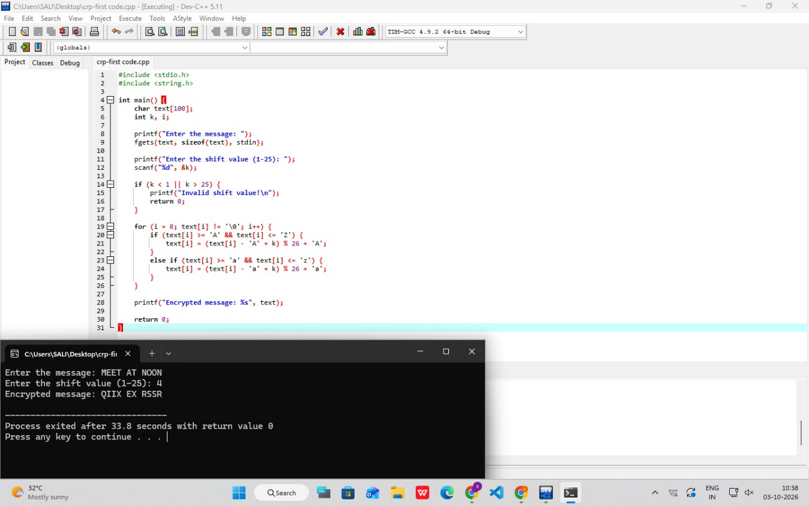

RESULT

Thus, the Caesar cipher was successfully implemented in C, and the plaintext was encrypted by shifting each alphabet character by the specified value k.

